**IDENTIFICATION AND CLASSIFICATION OF THE DESIGN ATTRIBUTES**

In the design process, the identification and classification of the design attributes is an important activity. It is necessary to remind that the design attributes can be four:

1. Objectives: they represent everything that the design will be and not what it will do. These are the things that the designer wants to achieve. For example: the designer wants that the product can be cheap for people to buy it.
2. Restrictions: these are the limitations and the aspects that the object must respect. An example can be that the designer has to make an object in steel.
3. Functions: these ones represent every activity that the object must do. For example, the product can generate heat to cook food.
4. Implementations: finally, the implementations represent the ways to execute the functions of the product. For example, the system generates heat to cook the food. [1]

This part of the design process allows the designer to create selected criteria that will be used in future stages of the project to develop the best possible solutions.

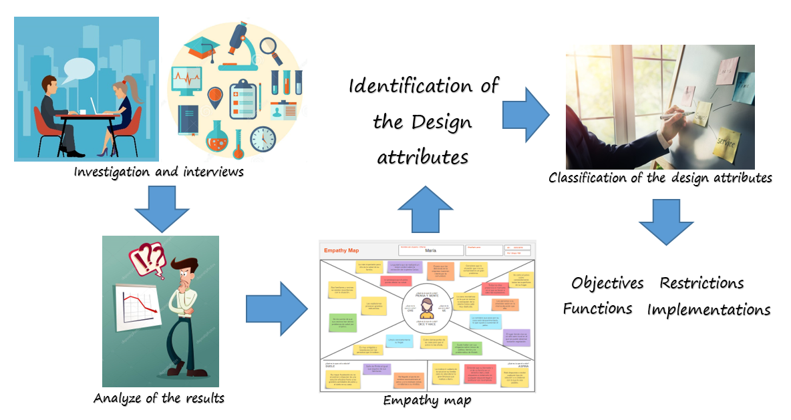Identification and classification of the design attributes.

**ACTIVITY**

The proposal presented in this document is to do a reverse engineering activity and to analyze all the parts that conform the system used to represent a real product. After analyzing every single part, the student has to identify if it corresponds to an objective, restriction, function or implementation.

For this activity, the group will use one of the projects that each member did the last semester. The options are three:

1. An air purifier, this machine uses a turbine and some filters.

2. A bracelet for elderly people used to monitor the vital signs.

3. A coffee beans sorter.

This activity will be focus on the design attributes and its main objective is that the students use the technology for learning about them.

The LittleBits are the tools that can make possible this activity. The idea is to represent the products mentioned before with these modular and intuitive units. For a better understanding of this part is necessary to know about the LittleBits.

**LITTLEBITS**

LittleBits is the name of the intuitive tools used in this project. These bits are a modular electronic system that can be connected with other bits thanks to the magnets at the end. There are a lot of types of LittleBits, each one has a unique function and the person who uses them can make different combinations as they want. The LittleBits make easier for students to participate in STEAM (Science, Technology, Engineering, Arts and Mathematics) [2]. [3]

LittleBits offer the possibility of being used in the classroom and in other spaces of creators by all kinds of people. Although LittleBits are tools for programming electronic circuits, it isn’t necessary to have advanced knowledge of electronic engineering to use them. In fact, the LittleBits’ goal is to be used by students of all courses and skills. In addition, there isn’t a single way to work with them, this is possible because they have an open design.

The open design is that one starts from the premise that the paths that allow the open communication and share information freely are those that benefit creativity. The open design aims to share all the creation process, distribution and manufacture of objects, ideas or systems so that other people can appropriate what they teach and apply them according to their needs. [4]

It is clear that LittleBits are a great way of applying the maker movement in the education, that is why they are the perfect tool for this activity. Their operation is simple, LittleBits were made to connect to each other through magnets, this doesn’t allow that they are connected in a wrong way, at the end all the people can make a complex circuit in a very simple way.

Among their most important components, it is the bit power which is formed by a 9-volt battery and a cable, this is the component that allows the operation of all circuits. On the other hand, the other components are classified according to a color code, this code is formed by three categories, the power category (blue) mentioned above is excluded.

* Input (Pink): receives signals and information from the outside and make possible the control of the circuit.
* Output (Green): Does an action, for example generates light or motion.
* Wire (Orange): it increases the size of the circuit, change its direction and add connections. The bits use cables to do this function. [5]

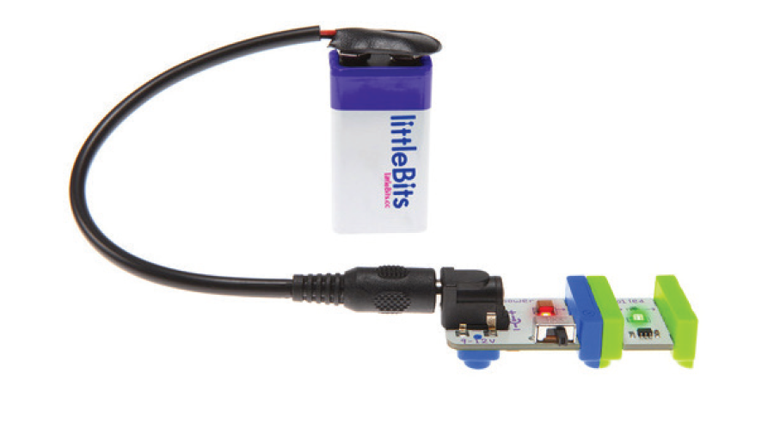

LittleBits. Recovered from <https://d2q6sbo7w75ef4.cloudfront.net/littleBitsEducatorsGuide_FINAL.pdf>

These four categories make possible the development of all kinds of circuits with any objective, from playing to solve a particular problem. It’s important to know that the bit power is always at the beginning and also the input bits only gives information to the following bits.

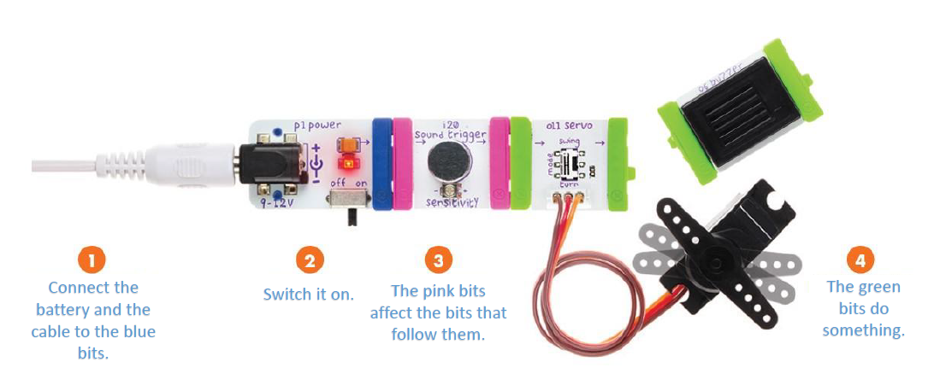

Parts of LittleBits. Recovered from <https://d2q6sbo7w75ef4.cloudfront.net/littleBitsEducatorsGuide_FINAL.pdf>

With the LittleBits one of the projects mentioned above will be represented (air purifier, bracelet for elderly people or coffee beans sorter) and while the activity advances, the built circuit will be disarming. It is expected that this activity resolves the doubts that students may have about the process of identification and classification of design attributes. [6]

**References**

1. Quintero, J. (2018). Design Attributes. [PowerPoint slides].
2. Ortega, B. (2016). ¿Qué es STEAM? [Online]. Recovered from <http://diwo.bq.com/que-es-steam-educacion/>
3. Hacedores. (2013). LittleBits: un kit para conectar diferentes módulos sin soldadura [Online]. Recovered from <https://hacedores.com/littlebits-un-kit-para-conectar-diferentes-modulos-sin-soldadura/>
4. [Manter. (2013). ¿Qué es el diseño abierto? / What is open design? [Online]. Recovered from http://www.arconvertblog.com/es/2013/02/26/que-es-el-diseno-abierto-what-is-open-design/](http://www.arconvertblog.com/es/2013/02/26/que-es-el-diseno-abierto-what-is-open-design/)
5. LittleBits. (2018). Shop / Wire [Online]. Recovered from <https://shop.littlebits.com/products/wire-bit>
6. LittleBits (2018). LittleBits - Educators Guide [Online]. Recovered from <https://d2q6sbo7w75ef4.cloudfront.net/littleBitsEducatorsGuide_FINAL.pdf>